Question 11

Implement ACLs to restrict traffic based on source and destination ports. Test rules by simulating legitimate and unauthorized traffic.

Approach

Make the below given network

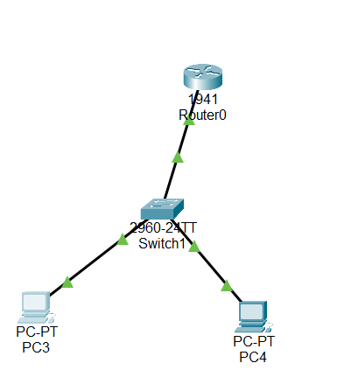

Now configure swith and create vlan’s

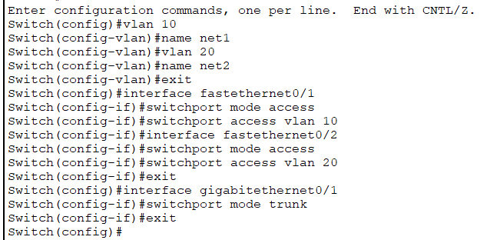

Now configure the router to communicate between inter vlan

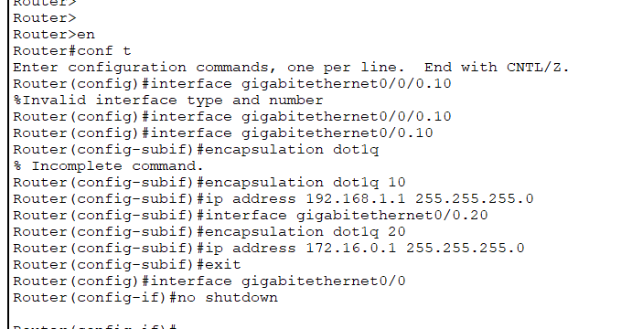

Now if you try to ping another network it works.

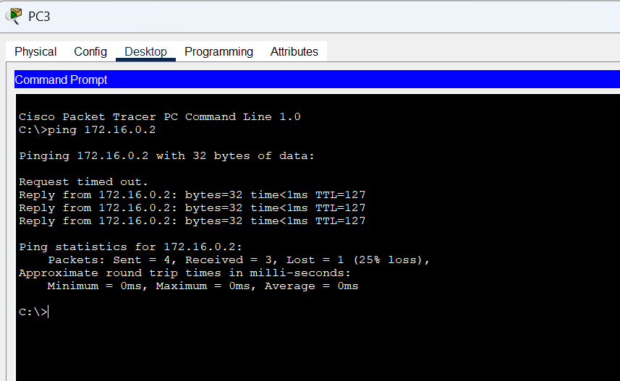

Now we are going to deny the packet from 192.168.1.2 using access-list

Configure the router with below command

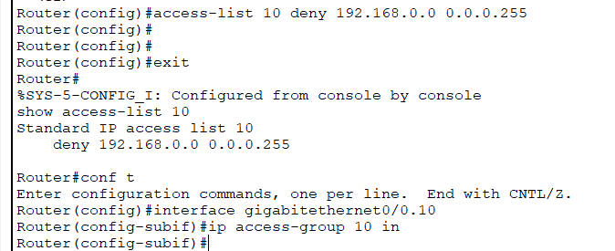

Now you can see the ping is unsuccessful

